39.37: a) 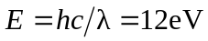
b) Find E for an electron with 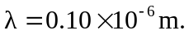
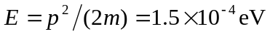
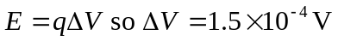
c) Same so same p.

